6/2022/1097/OUTLINE
Location: Land to the North of Bradmore Way, Bradmore Way, The Brookmans Estate, Brookmans Park
Proposal: Outline planning permission with all matters reserved except access, for up to 125 dwellings, a care facility for up to 60 bedrooms (Use Class C2), and a scout hut (Use Class F2)

Dear Sir or Madam,

This should be an extremely straight forward application for you to deal with as you have already done all the investigations into this site when working on your Local Plan:
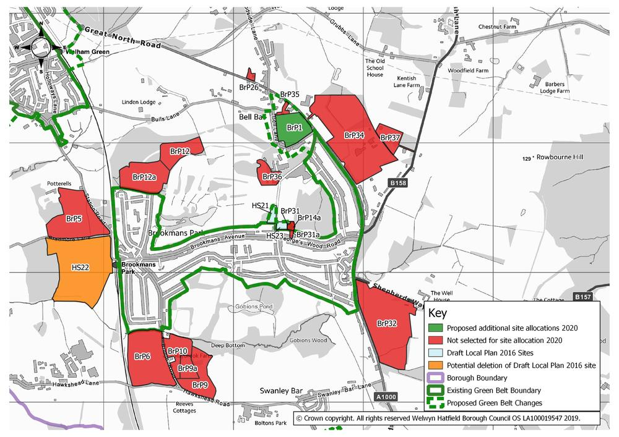
This site (BrP12a - land north of Peplins Way in the Local Plan) was 'not selected for site allocation’, presumably because you considered it unsuitable, you will know the reasons why:
http://consult.welhat.gov.uk/portal/planning_policy/sites_consultation_2020/proposed_changes_to_the_submitted_draft_local_plan_2016_site_allocations_2020?pointId=s1582037276910#section-s1582037276910

Some of your reasons for it not being selected were:
http://consult.welhat.gov.uk/portal/planning_policy/local_plan_consultation_january_2015/local_plan_consultation_january_2015?pointId=s1421325348608#section-s1421325348608
1. The site makes a significant contribution to the local and national Green Belt purpose
2. The site has also been assessed as having a low capacity to accommodate landscape change
3. The site lies within the strategic Green Belt gap between Hatfield and Potters Bar
4. The site, particularly when taken with WeG6 and WeG4b, would contribute to a significant cumulative impact on coalescence between settlements
Additionally, HHC as Highway Authority:
5. identified two junctions with the A1000, at Georges Wood Road and Swanley Bar Lane, as being locations where increased congestion and queuing were likely as a result of development of the proposed housing sites (2016) This proposal would make the situation a lot worse and more dangerous.
6. stated that help to alleviate the existing parking issues associated with the existing school at Bradmore Way was needed (2016). This proposal would make the situation a lot worse and more dangerous.
7. stated that improved access and the approach to Brookmans Park from the west would be needed (2016). This proposal would make the situation a lot worse and more dangerous.

I am sure there are a lot more of your reasons but unfortunately a lot of your Local Plan documents have been removed from the internet, so I am unable to note them down.

ALL my reasons to reject the application:

- Significantly inadequate infrastructure and services for such a disproportionate increase in population of the village.
  - Increase in the inadequacy and danger of the SINGLE access to the site through the village and along Bradmore Way (minor residential narrow roads, parked cars and school - NB: allegedly a traffic survey was done during ‘Walk to school week')
  - Increase of density of traffic and danger at junctions of A1000 with Georges Wood Road, Mymms Drive and Swanley Bar Lane
  - Unacceptable additional demand (including costs) on all services (roads, schools, doctors, hospitals, parking, public transport, water, sewage, etc)
- Large increase in pollution
- Contributes to the destruction of the character of the village
- Huge continuous traffic nuisance to residents living in the roads connected to the single access
- Huge traffic nuisance to residents using the village shops
- Pinch point at entrance to village will need addressing
- High rating of harm to the Green Belt & natural habitat.
- Loss of a significant contribution to maintaining the existing settlement pattern.
- Will increase coalescence - could have a significant impact on merging of settlements
- Loss of part of the strategic Green Belt gap.
- Loss of significant contribution to the local Green Belt purpose
- Loss of a significant contribution to a national Green Belt purpose
- Loss of high levels of visual and physical openness.
- Loss of Significant Contribution towards safeguarding the countryside from encroachment.
- Loss of Contribution to Preserving Setting.
- Site has a low capacity to accommodate landscape change.
- Would alter the character from rural to semi-urban due to necessary improvements to the highway network.
- Loss of land in agricultural use.
- Huge nuisance to existing residents during construction.

In view of the above I would urge you to reject the application.

Yours faithfully,

